**Leader Overview**



**Volume Overview**

**Get Going**

*The gift of the Holy Spirit was sent so that we might have power—power to go and make disciples. Some go to the farthest corners of the globe. Some only cross the street in front of their house. Still, God’s people always go. They go to work, school, grocery stores, kids’ soccer games, and family reunions. And wherever they go, they take their witness of Jesus with them. True believers live going and carrying out His mission.*

**Session Overview**

**Go Forth**

*In this* **Live** *session, kids will discover how Jesus sent out seventy-two disciples to share His love with others. These disciples didn’t take much with them. Instead, they paired up and moved out in faith to fulfill Jesus’ mission. Like these disciples, kids will learn that each of us has a role to play in Jesus’ mission, both individually and together in the community of believers.*

**Bible Lesson**

The Disciples Choose to Go

[Luke 10:1–20](https://ref.ly/logosref/Bible.Lk10.1-20)

**Faith Fact**

I have a role to play.

**Faith Verse**

[John 20:21](https://ref.ly/logosref/Bible.Jn20.21) (NLT)

[Jesus] said, “Peace be with you. As the Father has sent me, so I am sending you.”

**Preparing for the Session**

**Leader Preparation Time: 20–25 Minutes**

|  |
| --- |
| ***You Will Need***  ***Large Group***  *• Bible*  *• Worship songs (Song suggestions: “Zeal” (Lyric Video) by The Belonging Co; “To the Ends of the Earth” by Hillsong Worship; “Your Love Awakens Me” by (Lyric Video) Phil Wickham; “Follow You Anywhere” (Lyric Video) by Passion)*  *• For groups not using a phone or tablet only, add:*  *• Projector or TV*  *• Laptop*  *•* ***Faith Fact Slide***  *•* ***Faith Verse Video*** *or* ***Slide***  *•* ***Bible Lesson Video***  *•* ***Teaching Point Slides 1–3***  *• Whiteboard or piece of poster board*  *• Dry erase marker or marker*  *• Play money*  *• Backpack*  *• Pair of sandals*  *• Vinegar*  *• Baking soda*  *• Two clear containers*  *• 9 × 13-inch baking pan*  ***Small Group***  *• Bibles for kids in the group to share*  *• Ball*  *•* ***Small Group Activity Page****, one per kid*  *•* ***Small Group Activity Page Answer Page***  *• Pencils or pens, one per kid*  To access session content and videos from a computer, visit: [**BibleEngagementProject.com/downloads**](https://bibleengagementproject.com/downloads) |
| ***Getting Ready***  ***Large Group***  *• Download videos and slides if needed.*  *• Select worship song(s) and have them ready to play.*  *• Read the Bible Lesson Scripture to prepare for Teaching Time.*  *• Set up the whiteboard or poster board where the kids can see it.*  *• Pour vinegar into one of the clear containers and baking soda into the other clear container.*  ***Small Group***  *• Print copies of the* ***Small Group Activity Page****, one per kid.*  *• Print the* ***Small Group Activity Page Answer Page****, if needed.*  ***First time leading* Live *for Kids? Check out the*** [**Facilitator Guide**](https://0b769b0ed3569ef9d18b-f88d8272f61086866d50d048b43ef630.ssl.cf2.rackcdn.com/sites/biblengagementproject/Listen_Facilitator_Guide.pdf)**.** |

**Large Group**

**30 Minutes**

*See what’s needed at the beginning of the session.*

**Introduction**

How is everyone today? *(Group response)* The last couple of times we’ve been together, we’ve been talking about our part in Jesus’ mission. Remember, each of us has a purpose, and we can make a difference in our world.

Jesus uses us one by one to fulfill His mission, but He also expects us to work together. When we are part of a community, we are stronger and get more done.

• *Optional: Insert a personal story about a time when you worked with someone on a ministry mission. Try to choose something relatable to kids. For example, you may have been part of a student ministry team or traveled on a missions or outreach trip—or you might be serving in kids’ ministry alongside someone else as you lead this session now.*

**Faith Fact**

Jesus wants all of us to work together to fulfill His mission. There’s a place for everyone on His team. So our Faith Fact today is **I have a role to play.**

• *Show the* ***Faith Fact Slide.***

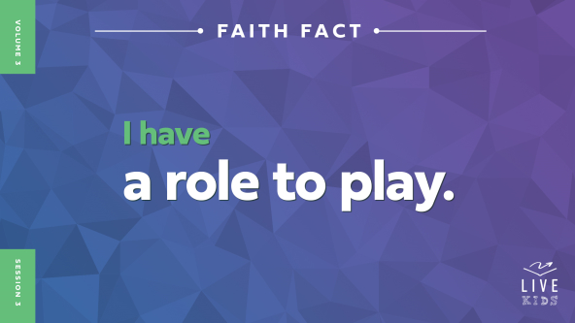

What does it mean to say you have a “role to play”? *(Allow responses.)* Think about the roles or parts that actors play in movies or shows. Each person in a movie has a specific character to play, and every role is different.

What would happen if only one person played her role and everyone else just didn’t show up? Could that make a movie? *(Group response)* No way! The same is true for Jesus’ mission. Each one of us must show up and play our role for His mission to move forward. Let’s say our Faith Fact together as a reminder—and I mean really say the words *together*. Say each word one at a time as I point at you. **I have a role to play.** Great job!

**Game**

|  |
| --- |
| *No prep is needed for this activity.* |

**Move as One**

We each have a purpose from God, but that doesn’t mean we always work alone. We’re called to work together in community. By moving together as one unit, we’re stronger and more effective in carrying out Jesus’ mission.

In today’s game, let’s practice moving together as one unit. The leader will do an exercise or movement and everyone else will try to copy them. Let’s see how well we can move together!

• *Begin by doing exercises and movements slowly, so the kids have a lot of time to copy them. As the game progresses, speed up and change the exercises and movements often to make it harder for them to keep up.*

• *Optional: Choose new leaders throughout the game.*

You did a great job moving together! We needed everyone’s help, because everyone has an important role to play. If one person does their own thing or works against the rest of the group, it can keep everyone from being effective. The same is true when it comes to Jesus’ mission. We must work together to share His love, so everyone can know how amazing Jesus is.

**Worship**

Let’s think about how amazing Jesus is as we worship Him together today! Did you know that Jesus loves it when we worship Him together? [Matthew 18:20](https://ref.ly/logosref/Bible.Mt18.20) says that when two or more of His followers come together, Jesus is there too! That means He is right here with us as we worship Him by singing.

• *Lead the kids in singing one or two praise songs. See suggestions at the beginning of the session.*

**Bible Lesson**

Thanks for worshipping with me today. I love worshipping Jesus on my own, but there is something extra special about worshipping Him with other believers. Worship isn’t the only thing that can be better when we come together. In our Bible story today, Jesus sent His disciples on a mission to tell people about the kingdom of God. He didn’t send any of them to go on the mission alone. Instead, Jesus told them to go with a partner. They had to use their faith and work together. Before we learn more about the disciples and their mission, let’s pray.

**Prayer**

|  |
| --- |
| *Dear Jesus, we are so thankful that You are here with us today. Help us learn from Your disciples how we can obey and serve You better. Amen.* |

**Video Intro**

Just before we look at the Bible story, let’s watch this video.

• *Play* ***Bible Lesson Video.***

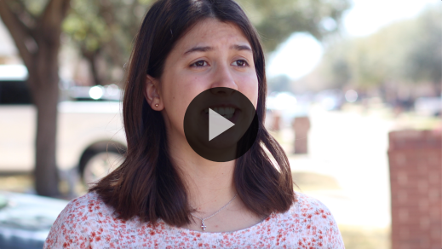

**Bible Story**

**The Disciples Choose to Go**

That video really got us ready for our Bible story! When you think of Jesus’ disciples, do you think of farmers like Isa’s example in the video? *(Group response)* I usually think about the twelve closest disciples Jesus chose. But did you know there were a lot more people who followed Jesus? *(Group response)*

The twelve disciples were some of Jesus’ closest followers and friends. But many more people chose to follow Jesus as He traveled around, teaching and healing people. Some of those followers were His disciples too. What qualities do you think Jesus looked for in a disciple? *(Allow responses.)* Those are all great thoughts. We can tell from today’s Bible story that Jesus was looking for disciples who were full of faith and willing to work together.

**Teaching Time**

|  |
| --- |
| ***You Will Need***  *• Whiteboard or piece of poster board*  *• Dry erase marker or marker*  *• Play money*  *• Backpack*  *• Pair of sandals*  *• Vinegar*  *• Baking soda*  *• Two clear containers*  *• 9 × 13-inch baking pan*  ***Getting Ready***  *• Set up the whiteboard or poster board where the kids can see it.*  *• Pour vinegar into one of the clear containers and baking soda into the other clear container.* |

The Bible tells us Jesus chose seventy-two other disciples to send out on a very important mission. We don’t know a whole lot about these disciples. But think about all the people who heard about Jesus because these disciples obeyed and played their role in Jesus’ mission!

It wasn’t an easy thing Jesus told them to do. Let’s find out why. Grab your Bible or pull up a Bible app on your device. Turn to [Luke 10:1–20](https://ref.ly/logosref/Bible.Lk10.1-20).

• *In order to keep Large Group time moving along, we recommend that the leader reads the Scripture portions aloud.*

• *Optional: Remind the kids to mark this place with a bookmark, so they can read it on their own at home.*

**1. Jesus sent the disciples out in pairs.**

• *Show the* ***Teaching Point 1 Slide.***

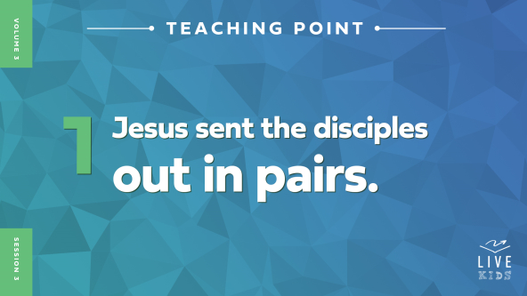

• *Read* [*Luke 10:1–3*](https://ref.ly/logosref/Bible.Lk10.1-3)*.*

Jesus chose seventy-two disciples especially for this mission. This wasn’t the twelve disciples we usually think of. Jesus had already sent them out on a similar mission. Did Jesus send these seventy-two disciples out all alone? *(Group response)* No, He didn’t! Jesus sent them in pairs. Let’s do a simple math problem to figure out how many pairs that would make.

• *Go to the whiteboard and write this math equation on it: 72 divided by 2.*

Who can solve this math problem for us? *(Group response)*

• *Choose a kid to solve the math problem. If the kid gets it wrong, help everyone solve for the correct answer.*

That’s correct! That makes thirty-six pairs of disciples who were sent to all the towns and places Jesus planned to visit. Does that sound like an important job? *(Group response)* It seems like a very important mission to me.

Does seventy-two people sound like a lot? *(Group response)* It does to me, but Jesus said it wasn’t enough to reach all the people who needed to hear about Him. So He told His disciples to pray for even more workers. How do you think more disciples could find out about Jesus and choose to follow Him? *(Allow responses.)* One way was by hearing about Him from people like these seventy-two disciples!

Imagine you were one of these disciples going on Jesus’ important mission. What are some items you would plan to bring with you? *(Allow responses.)* Those are some great answers. I know I would pack money, lots of clothes, shoes, soap, toothpaste, a toothbrush, and a bunch of snacks. Then I’d be ready to go. Let’s find out if these disciples packed like I would.

**2. Jesus told the disciples to have faith.**

• *Show the* ***Teaching Point 2 Slide.***

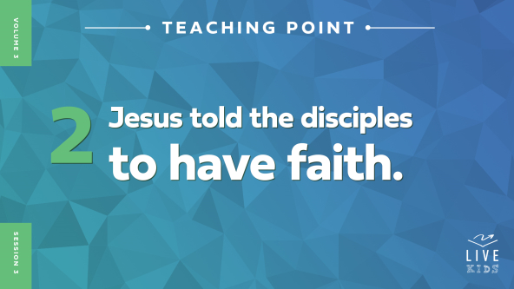

• *Read* [*Luke 10:4–15*](https://ref.ly/logosref/Bible.Lk10.4-15)*.*

Keep imagining you’re one of these disciples. After listening to Jesus say all this, what would you be thinking about the stuff you packed? *(Allow responses.)* It doesn’t sound like I would have packed like Jesus wanted us to. Jesus told the disciples specifically not to bring any money. *(Hold up the play money.)* They couldn’t take a bag or backpack to pack stuff in. *(Hold up the backpack.)* They couldn’t even take an extra pair of shoes. *(Hold up the pair of sandals.)*

Why do you think Jesus told the disciples not to bring anything with them? *(Allow responses.)* He wanted them to move in faith—to believe Him enough to obey. He didn’t want them relying on their stuff to help with the mission. Jesus wanted them to rely on Him. He would make sure they had everything they needed along the way.

Jesus also wanted the disciples to talk to people in the towns they were going to. The disciples would need to meet people so they could find somewhere to stay and food to eat. This would let the disciples see if the people would accept them. If the people welcomed the disciples, what did Jesus say they should do? *(Allow responses.)* Jesus wanted them to accept their hospitality, heal sick people, and share about the kingdom of God.

But what did Jesus say the disciples should do if a town didn’t welcome them? *(Allow responses.)* He wanted the disciples to leave! He said they should wipe the dust off their feet and warn the people that they would be judged by God. Do you think this happened in some of the towns? *(Group response)* It probably did, but as far as we know, none of the disciples quit or gave up. They kept going on the mission Jesus called them to do. Each of the disciples had a role to play. Do you think it took a lot of faith to carry out Jesus’ instructions? *(Group response)* It did! But thankfully the disciples weren’t on their own.

**3. Jesus equipped the disciples to complete the mission.**

• *Show the* ***Teaching Point 3 Slide.***



• *Read* [*Luke 10:16–20*](https://ref.ly/logosref/Bible.Lk10.16-20)*.*

Could the disciples have done this mission on their own? *(Group response)* I don’t think so. But the good news is, they didn’t have to do it on their own! Jesus got them ready to do the job. He also told them if anyone accepted the message they were sent to share, they were accepting Jesus’ message. But if anyone rejected their message, those people were rejecting Him—and God. Wow!

The disciples by themselves were like this baking soda. *(Hold up the container of baking soda.)* Baking soda can do some things on its own, but it needs another ingredient—a partner—to really come alive. Jesus is like this vinegar. *(Hold up the vinegar.)* When Jesus sent His disciples out, He equipped them to do the job.

• *Hold the baking soda container over the 9 × 13-inch baking pan to catch the overflow.*

• *Pour the vinegar into the baking soda until it bubbles up and out of the container.*

Because they were sent by Jesus, the disciples healed people, did miracles, and made demons come out of people by God’s power. If they had tried to complete this mission alone, they would have failed. But with Jesus, they could do it.

**Prayer and Response**

*Consider playing a worship song softly in the background while kids pray.*

The disciples each had a role to play in Jesus’ mission. Jesus sent them out. But each one of them had to show up, have faith, and work together. None of them had to go on their own. As we pray today, we’re going to pair up like Jesus’ disciples did. Find a partner, and ask them what they need prayer for. Then pray for each other’s needs out loud. We are stronger when we stick together.

• *Help kids pair up and pray for each other’s needs.*

• *If a kid doesn’t have a prayer partner, help them find one or join a group.*

**Prayer**

*Optional: Have the kids repeat phrases of the prayer after you.*

|  |
| --- |
| *Dear Jesus, thanks for giving me a role to play in Your mission. Help me to work together with other believers to make more disciples for You. Amen.* |

**Faith Verse**

Our Faith Verse tells us that God sent Jesus, and Jesus is sending each of us. Let’s say it together.

• *Play* ***Faith Verse Video.***



[John 20:21](https://ref.ly/logosref/Bible.Jn20.21)

[Jesus] said, “Peace be with you. As the Father has sent me, so I am sending you.”

Why did God send Jesus? *(Allow responses.)* To die in our place and forgive our sins! And why is Jesus sending us? *(Allow responses.)* To tell people about Him and make even more disciples for Jesus.

**Faith Fact**

It’s powerful to know that Jesus is sending us out to fulfill His mission. That’s why our Faith Fact is so important. Say it with me. **I have a role to play.**

• *Show the* ***Faith Fact Slide.***



Point to yourself, and let’s say it again. **I have a role to play.** Great job! Let’s keep learning about the role Jesus has for us.

• *Dismiss kids to Small Group time or to go home if your group time ends here.*

**Small Group**

**30 Minutes**

*This section can be done in conjunction with the large group or on its own if you do small groups with your kids. During Small Group time, the goal is to connect the kids with the Word of God and to each other. All activities are led by the small group leader.*

**Group Connection**

**Name That Role!**

|  |
| --- |
| *No prep is needed for this activity.* |

We all have a role to play in Jesus’ mission, just like there are many different roles or jobs in our communities. What is a role or job you would love to do when you get older? *(Allow responses.)*

We’re going to have some fun role-playing some of these jobs we just mentioned. But just like in our Bible story, you don’t have to complete this mission alone. You can choose a partner and then work together to act out the role I’ll tell you.

• *Help kids pair up and assign one of the roles to each pair.*

• *Teacher*

• *Doctor*

• *Police officer*

• *Pastor*

• *Firefighter*

• *Musician*

• *Athlete*

• *Artist*

• *Chef*

• *Stay-at-home parent*

• *Give kids time to practice acting out their role.*

• *Have pairs take turns acting out their role and letting the rest of the group guess.*

• *Play again if there are extra roles.*

That was a lot of fun! I can’t wait to see the role Jesus gives each of you as you get older. But you don’t have to wait to be part of His mission. You can start playing that role right now!

**Bible Lesson Recap**

• *If small group activities are not immediately following large group time, you may want to read the Bible story passage before the discussion.*

|  |
| --- |
| ***You Will Need***  *• Bibles for kids in the group to share*  *No prep is needed for this activity.* |

**Bible Story Review: The Disciples Choose to Go** [**Luke 10:1–20**](https://ref.ly/logosref/Bible.Lk10.1-20)

Let’s see what we remember from our Bible story. Who did Jesus choose? *(Allow responses.)* He chose seventy-two disciples and sent them out to the places He planned to visit. The disciples were on a mission to see who would welcome them and listen to their message.

What did Jesus tell them to pack for their mission? *(Allow responses.)* They couldn’t bring any bags, extra money, or clothes. Jesus wanted them to move forward in faith and rely on Him for their needs. Were the disciples successful? *(Group response)* Yes! The Bible says they performed many miracles and healings. Did they do any of that on their own? *(Group response)* No, we can’t heal people on our own. Jesus gave them power them to go out and make disciples for Him.

• *Optional: Give each kid a Bible and read the Bible story together.*

**Group Discussion**

*Feel free to use all or just a few questions as a jumping-off place for good discussion. Questions marked with * are designed for more conversation. Adjust the questions based on the age or maturity of your group. Typically, older kids will be able to dive a little deeper than younger ones.*

**Questions**

How many disciples were sent out by Jesus in today’s story?

How do you think these disciples felt when Jesus told them to not take anything with them?

* Do you prefer to do things alone or with others? Why?

* Why do you think Jesus sent these disciples out in pairs?

* What are some ways we can be stronger when we work together?

How do you think these disciples responded if they were rejected?

Do you think going on this mission changed these disciples? If so, how?

* What is something you are facing right now that requires you to have faith? Why?

**Live It**

|  |
| --- |
| *No prep is needed for this activity.* |

**Faith Fact**

Our Faith Fact today is **I have a role to play.** Say that with me one more time. **I have a role to play.** When these disciples returned from their mission, they were excited about what had happened. They saw Jesus’ power at work in their life, and they saw what His power could do for others too!

**Challenge**

I want to challenge you to find a partner this week. Choose someone who is also a Christian, and decide together to do something for God. Maybe you could ask them to pray with you. You could work together to help out someone who doesn’t know Jesus. Or you could tell someone about Jesus together. It’s a lot easier to make disciples for Jesus when we do it together.

**Prayer**

*Finish group discussion by sharing prayer requests and praise reports. Keep track of your small group’s prayer requests and review them each time you meet.*

• *Have kids share and pray for each other’s prayer requests.*

|  |
| --- |
| *Dear Jesus, help me do whatever role You have for me. Please help me to have faith, and please give me Your power so I can reach others for You. Amen.* |

**Faith Verse Review**

|  |
| --- |
| ***You Will Need***  *• Ball*  *No prep is needed for this activity.* |

Our Faith Verse reminds us that Jesus is sending us out like He sent out the seventy-two disciples in our Bible story. Let’s review our Faith Verse together.

• *Show* ***Faith Verse Video.***



[John 20:21](https://ref.ly/logosref/Bible.Jn20.21)

[Jesus] said, “Peace be with you. As the Father has sent me, so I am sending you.”

Who can tell me the Faith Verse from memory? *(Allow responses.)* That was awesome. I think you’re ready for our next game!

**Faith Verse Fun**

**Lightning Verse**

We’re going to play Lightning Verse to see just how fast we can say the Faith Verse. But there is a catch! We have to work together to say it one word at a time. We’ll get in a circle and pass the ball around. When you have the ball, say the next word in the Faith Verse—but don’t say a word until you catch the ball. Let’s see how fast we can say the verse together!

• *Pass the ball around the circle and say the verse.*

• *Play a few times to see if the group can do it faster each time.*

You were lightning fast at saying the Faith Verse! Hopefully, we all have it memorized after playing that game.

**Activity Page**

**Find the Role**

|  |
| --- |
| ***You Will Need***  *•* ***Small Group Activity Page****, one per kid*  *•* ***Small Group Activity Page Answer Page***  *• Pencils or pens, one per kid*  ***Getting Ready***  *• Print copies of the* ***Small Group Activity Page****, one per kid.*  *• Print the* ***Small Group Activity Page Answer Page****, if needed.* |

Are you ready for a fun word search? Let’s do it!

• *Hand out a copy of the* ***Small Group Activity Page*** *and a pencil to each kid.*

Try to find all the roles in the word search. But our Bible story was all about a big challenge that Jesus gave His disciples. So your Activity Page has an extra challenge too. Each word you find has a letter circled in it. You’ll match that circled letter with the number by that word in the list. That tells you where the letter goes to reveal a very important role for each of us to play. Are you up to the challenge? *(Group response)* I have faith in you!

• *Assist kids as needed to finish the page.*

**Dismissal**

The seventy-two disciples Jesus chose to send out were incredible examples for us to have faith and work together in Jesus’ mission. Are you willing to do whatever it takes to fulfill the role Jesus has called you to do? *(Group response)* Let’s pray and ask God to give us the same faith the disciples had to go forth and make disciples for Him.

**Prayer**

|  |
| --- |
| *Dear God, thank You for giving each of us the faith we need and sending us out to be a part of Your mission. Help us to be willing to do whatever it takes to make disciples for You. Amen.* |

**Faith Fact Recap**

• *Show the* ***Faith Fact Slide.***



Thanks for partnering with me to have a great time together today. Before we go, let’s say the Faith Fact together one more time. **I have a role to play.** Never forget that! Jesus wants every one of us to work together to fulfill His mission. See you next time!

• *Send home the* ***Small Group Activity Page.***

• *Remind parents that there are* ***Family Devotions*** *available on the app to do with their kid.*

• *Tell everyone the date and time for the next session.*